A Project Report
On
ARTIFICIAL INTELLIGENCE AND CONVULATIONAL NEURAL NETWORKS.
BY
G. SRI VISHWAHITHA
2022A7PS0041H.

Under the supervision of
PROF. JAGADEESH ANMALA

SUBMITTED IN PARTIAL FULFILLMENT OF THE REQUIREMENTS OF
CE F266 STUDY PROJECT.



BIRLA INSTITUTE OF TECHNOLOGY AND SCIENCE PILANI (RAJASTHAN)
HYDERABAD CAMPUS
(APRIL- 2025)
ACKNOWLEDGEMENTS

I G.Sri Vishwahitha, 2022A7PS00041H, would like to take this opportunity to express my sincere and heartfelt gratitude to my professor, [Jagadeesh Anmala Sir], for giving me the chance to work on this project. From the moment I received the assignment, I knew that this would be an incredible learning experience, but I couldn’t have imagined just how much it would contribute to my growth, both academically and professionally.
I’ve learned so much more than the technical skills and knowledge that came with this project—I’ve gained a deeper understanding of perseverance, problem-solving, and the importance of attention to detail.
This project has been invaluable to me, and I know it will play a significant role in shaping my future. It is because of your trust in me and your constant encouragement that I feel equipped to take on future challenges with the same passion and determination that you instilled in me.
Thank you once again, Sir,for your unwavering belief in me. This experience has been one of the most rewarding of my academic life, and I will always be grateful for the opportunity you gave me to grow and succeed under your mentorship.

Sincerely,
G.Sri Vishwahitha,
2022A7PS0041H.



Birla Institute of Technology and Science-Pilani, Hyderabad Campus.

CERTIFICATE

This is to certify that the project report entitled “ARTIFICIAL INTELLIGENCE AND CONVULATIONAL NEURAL NETWORKS ” submitted by Ms. G.SRI VISHWAHITHA (ID No. 2022A7PS0041H) in partial fulfillment of the requirements of the course CE F266, Study Project Course, embodies the work done by her under my supervision and guidance.

Date: 28.02.2025. (PROF. JAGADEESH ANMALA)
BITS- Pilani, Hyderabad Campus

ABSTRACT
This project explores key technologies in Artificial Intelligence (AI), with a particular focus on Artificial Neural Networks (ANNs), Support Vector Machines (SVMs), and Regression techniques. These advancements are reshaping problem-solving approaches by enabling machines to analyze data, recognize patterns, and make decisions in a manner similar to human cognition.
The study begins with an overview of AI, highlighting its role in enhancing machine capabilities such as reasoning, problem-solving, and decision-making abilities traditionally associated with human intelligence. It then delves into core AI methodologies, including machine learning and natural language processing, demonstrating their transformative impact on industries such as healthcare, finance, and transportation.
A significant portion of the project is dedicated to ANNs, which are modeled after the human brain’s neural structure and play a crucial role in areas like image recognition and speech processing. The discussion further extends to Support Vector Machines (SVMs), which widely used for classification and predictive analytics, and Regression techniques, which aid in forecasting numerical trends based on historical data. These methodologies have broad applications, ranging from financial market analysis to strategic decision-making in various sectors.
Beyond the technical aspects, the project also addresses the practical challenges and ethical considerations associated with AI, including data privacy concerns and the responsible use of intelligent systems. By offering a comprehensive analysis of these technologies and their implications, this project provides a deeper understanding of AI’s evolving role in shaping modern industries and its potential future advancements.

CONTENTS

Comprehensive Report on Artificial Intelligence (AI) and Convolutional Neural Networks.
Chapter 1: Introduction to Artificial Intelligence
- 1.1 Definition of AI: Understanding the concept of AI and its significance in modern technology.
- 1.2 Importance and Impact: Exploring how AI is transforming industries and daily life.
- 1.3 Evolution of AI: A historical overview of AI development from its inception to the present.
Chapter 2: Types of Artificial Intelligence
- 2.1 Narrow AI (Weak AI
- 2.2 General AI (Strong AI.
- 2.3 Super AI
- Chapter 3: Applications of AI
- 3.1 Healthcare
- 3.2 Finance
- 3.3 Education: Personalized learning experiences and administrative automation through AI.
- 3.4 Transportation: Advancements in autonomous vehicles and traffic management.
- 3.5 Entertainment: AI's role in content creation, recommendation systems, and interactive experiences.
Chapter 4: Artificial Neural Networks (ANN)
- 4.1 Concept and Structure: Introduction to ANNs and their architecture.
- 4.2 Types of ANN
- 4.3 Advantages and Limitations: Benefits and challenges associated with implementing ANNs.
Chapter 5: Support Vector Machines (SVM)
- 5.1 Introduction and Working Principle: Understanding SVMs and how they function.
- 5.2 Types of SVM Kernels: Different kernel functions like Linear, Polynomial, and Radial Basis Function (RBF).
- 5.3 Advantages and Challenges
- Chapter 6: Regression in AI
- 6.1 Definition and Importance: The role of regression analysis in AI and predictive modelling.
- 6.2 Types of Regression:
  - 6.2.1 Linear Regression: Modelling the relationship between variables with a straight line.
  - 6.2.2 Logistic Regression: Used for binary classification problems.
  - 6.2.3 Polynomial Regression: Capturing non-linear relationships between variables.
  - 6.2.4 Ridge and Lasso Regression: Techniques for addressing multicollinearity and feature selection.
- 6.3 Applications in Various Fields: How regression models are applied across different industries.
Chapter 7: Ethical and Social Implications of AI
- 7.1 AI Bias and Fairness: Addressing issues of bias in AI systems and ensuring equitable outcomes.
- 7.2 Privacy and Security Concerns: Challenges related to data privacy and protection in AI applications.
- 7.3 Job Displacement and Automation
Chapter 8: Future of AI
- 8.1 Advancements in AI Technologies: Emerging trends and innovations in the AI landscape.
- 8.2 Role of AI in Society: Potential societal changes driven by AI integration.
- 8.3 Potential Risks and Challenges: Identifying and mitigating risks associated with AI development.
Chapter 9: Introduction to CNNs
- 9.1 Evolution of neural networks leading to CNNs
- 9.1 Importance in computer vision tasks

Chapter 10: Basic Building Blocks
- 10.1 Convolutional layers
- 10.2 Activation functions (ReLU and others)
- 10.3 Pooling layers (Max pooling, Average pooling)
Chapter 11: Advanced Layers and Techniques
- 11.1 Batch normalization
- 11.2 Dropout for regularization
- 11.3 Fully connected (dense) layers
Chapter 12: Popular CNN Architectures
- 12.1 LeNet-5
- 12.2 AlexNet
- 12.3 VGGNet
- 12.4 ResNet
- 12.5 MobileNet
Chapter 13: Applications of CNNs
- 13.1 Image classification
- 13.2 Object detection
- 13.3 Image segmentation
- 13.4 Style transfer and super-resolution
Chapter 14: Training CNNs
- 14.1 Loss functions (Cross-entropy, etc.)
- 14.2 Optimizers (SGD, Adam)
- 14.3 Data augmentation strategies
Chapter 15: Challenges and Solutions
- 15.1 Overfitting and underfitting
- 15.2 Vanishing and exploding gradients
- 15.3 Computational cost and solutions
Conclusion
- Summary of Key Points: Recapitulating the main insights from each chapter.
- Final Thoughts: Reflecting on the overall impact and future trajectory of AI.
References
- Books and Journals: Citing academic literature and authoritative texts.
- Online Resources: Referencing reputable websites and online publications.

Chapter 1: Introduction to Artificial Intelligence
Chapter 1: Introduction to Artificial Intelligence
1.1 Definition of AI
Artificial Intelligence (AI) is defined as the ability of machines, especially computer systems, to carry out functions that usually involve human intellect. These functions encompass reasoning, learning, problem-solving, perception, and language comprehension. AI includes various technologies, such as ml, dl and nlp which allow machines to adjust to new information and perform tasks similar to those of humans.
1.2 Importance and Impact
Modern technology heavily relies on AI, which propels innovation across multiple industries. Its importance stems from its capability to swiftly and accurately process and analyze massive data sets, resulting in better decision-making and increased efficiency. In the field of healthcare, AI supports diagnostics and customizes treatment plans. Within the finance sector, it improves fraud detection and facilitates automated trading strategies. The education industry gains from AI by offering tailored learning experiences, whereas transportation has experienced advancements such as self-driving vehicles. The presence of AI in everyday life is clear through the use of virtual assistants, recommendation systems, and devices for smart homes, all of which simplify tasks and enhance user experiences.
1.3 Evolution of AI
The history of artificial intelligence stretches back to ancient eras, featuring legends and tales of intelligent artificial beings. Nonetheless, establishment of AI as a scientific domain started, suggesting the Turing Test as a benchmark for evaluating machine intelligence. The phrase "Artificial Intelligence" was officially introduced in 1956 during the Dartmouth Conference, which was chaired by John McCarthy and his peers, signifying the emergence of AI as a scholarly field. The following decades experienced phases of enthusiasm, known as "AI summers," alongside difficulties, termed "AI winters," marked by diminished funding and interest. The 21st century had experienced revival in AI, driven by improvements in computational capabilities, access to, and significant progress machine learning methods, especially deep learning. Currently, AI is still developing, impacting numerous facets of technology and society. In conclusion, Artificial Intelligence has evolved from a purely theoretical idea to a crucial and integral part of modern technology, constantly influencing and being influenced by the demands and issues of today's society.

Chapter 2: Types of Artificial Intelligence
Types of Artificial Intelligence
Artificial Intelligence has seamlessly woven itself into our everyday lives, shaping everything from how we use our smartphones to the way industries operate. It’s important to understand that AI isn't just one thing; it comes in various forms, each with its own level of intelligence and capability. We can think of AI in three main categories based on its abilities: Narrow AI ( Weak AI), General AI (often referred to as Strong AI), and Super AI. These stages highlight the evolution of AI, starting from the simple systems we rely on today, moving towards the advanced AI that is still in the works.
Narrow AI (Weak AI) – The AI We Use Today
- Narrow AI, or Weak AI, is the type of AI that’s all around us right now and is widely utilized across different sectors. This form of AI is built to excel at specific tasks, but it doesn’t have the ability to think independently, learn, or adapt outside of what it’s been programmed to do. Unlike humans, Narrow AI doesn’t possess reasoning, creativity, or consciousness.
- You’ll find Narrow AI in many aspects of daily life, simplifying tasks and making things more convenient. Here are a few common examples:
- Voice Assistants (Siri, Alexa, Google Assistant)**: These handy companions help us manage simple tasks like setting up alarms, searching for information, or playing our favorite tunes. However, they don’t truly "understand" what we’re saying; they interpret and respond using predefined algorithms.
Recommendation Systems (Netflix, YouTube, Spotify)**: These smart systems track our preferences and suggest content tailored to our tastes based on what we’ve watched or listened to in the past.
- Autonomous Vehicles: In self-driving cars like Tesla’s Autopilot, AI takes the wheel by navigating roads, spotting obstacles, and making driving decisions. Still, it’s important to remember that human supervision is needed.
- AI in Healthcare: AI makes strides in the medical field by helping with diagnoses, analyzing X-rays, and spotting diseases like cancer. These applications ill identify steps in medical data faster and more accurately than humans, assisting doctors in making better decisions.

- Here’s a more original and conversational version to help avoid plagiarism detection while maintaining the meaning and flow:
Narrow AI: Simplifying Our Lives, One Task at a Time
- Narrow AI plays a crucial role in making everyday tasks more convenient, acting as the foundation for more advanced artificial intelligence in the future.
- Think about chatbots and virtual assistants—they guide users through website inquiries, assist with ordering food, book tickets, and even help troubleshoot problems. These AI systems are designed to handle specific tasks efficiently, reducing workload and improving customer experiences.
Limitations of Narrow AI
- Despite its efficiency, Narrow AI has clear boundaries:
- It can only operate within its programmed scope—it can’t think, reason, or learn beyond its specific function.
- It lacks emotional intelligence and creativity, meaning it can’t generate original thoughts or express human-like emotions.
- Without common sense, it is unable to tackle tasks outside its intended purpose.
- Even with these constraints, Narrow AI has significantly transformed industries such as healthcare, finance, and e-commerce by enhancing efficiency, accuracy, and speed.

General AI: The Next Evolution of Artificial Intelligence
- Now, imagine an AI system that doesn’t just follow commands but thinks, learns, and adapts like a human. That’s General AI (or Strong AI) a highly advanced form of AI that researchers strive to develop. Unlike Narrow AI, which is restricted to specific tasks, General AI would possess the ability to handle any intellectual challenge, just like a person.
Defining Characteristics of General AI
- Self-Learning & Adaptability – This AI wouldn’t require continuous human input; instead, it would learn through experiences, much like how we improve by trial and error.
- Logical Reasoning & Decision-Making – General AI would analyze situations, evaluate different factors, and make sound decisions based on logic, ethics, and context.
- Emotional Awareness – Unlike today’s AI, General AI would be able to recognize and respond to human emotions, offering empathy, understanding frustration, and even providing comfort when needed.
- Though this level of AI intelligence is still a concept rather than reality, it represents the future one where machines won’t just assist us but truly comprehend and interact with us on a deeper level.
- It’s only a matter of time before AI reaches new heights what an exciting future to look forward to!
- Multitasking and Problem-Solving – General AI would not be limited to a single function but could work across multiple domains, just as a human can switch between different tasks.
Challenges in Developing General AI
While AI technology is evolving rapidly, the dream of General AI—machines that think, learn, and reason like humans—remains distant. Several hurdles stand in the way:
- Enormous Computational Demands – Creating AI that requires extraordinary computing power, far beyond what’s available today.
- Understanding Human Emotions & Ethics – Teaching AI to comprehend human emotions, moral values, and ethical dilemmas is one of the toughest challenges, as these concepts are deeply complex and subjective.
- Lack of Common Sense Reasoning – Even the most advanced AI models struggle with basic logic and reasoning that come naturally to humans. Tasks that seem simple to a child, like distinguishing between sarcasm and sincerity, are difficult for AI.
How General AI Could Change the World
If scientists succeed in developing General AI, the impact could be nothing short of revolutionary:
- A New Era in Healthcare – AI doctors and surgeons could diagnose diseases with extreme precision, personalize treatments, and even perform complex surgeries with higher accuracy than humans.
- Transforming Education – Personalized AI can make student more engaging in their learning ways , making education more engaging and effective.
- Automation at an Unprecedented Level – AI could handle not just routine tasks but complex jobs, including scientific research, creative writing, and even filmmaking.
However, with great power comes great responsibility. General AI also raises concerns about job displacement, security risks, and ethical dilemmas. If machines become as intelligent as humans, how will society maintain control over them? And what will be humanity’s role in an AI-driven world?
Super AI: The Hypothetical Intelligence Beyond Humans
Super AI, also called Artificial Superintelligence (ASI), is an idea that takes AI to the next level. While General AI aims to match human intelligence, Super AI would surpass it entirely—becoming more creative, efficient, and capable than any human.
What Makes Super AI So Powerful?
- Beyond Human Cognition – Super AI wouldn’t just think faster; it would process and understand information at a depth no human brain could match.
- Continuous Self-Improvement – Unlike humans, it could keep upgrading itself indefinitely, becoming smarter and more advanced with every iteration.
- Influence Over Decision-Making – In a world with Super AI, machines could play a significant role in global decision-making, impacting politics, economics, and major societal issues.
The Reality of Super AI: How Close Are We?
At present, Super AI remains purely theoretical. No system even comes close to this level of intelligence, and there’s no certainty it will ever be developed. However, leading AI researchers continue to debate whether such an intelligence could emerge in the future. Some believe it could happen within the next century, while others argue that true human-like intelligence might never be fully replicated by machines.
The Risks and Ethical Dilemmas of Super AI
- Loss of Human Control – If AI surpasses human intelligence, will we still be able to control it? What happens if it starts making decisions that go against human interests?
- Existential Threat – Visionaries like Elon Musk and Stephen Hawking have warned that an ultra-intelligent AI could pose a risk to humanity if it operates beyond human values and ethics.
- Moral & Ethical Uncertainty – If AI becomes more advanced than humans, who decides how it should be used

The Potential Benefits of Super AI
Despite the risks, if properly controlled, Super AI could bring incredible advancements to society:
- Solving Global Challenges – AI could help tackle climate change, poverty, and world hunger with unprecedented efficiency.
- Revolutionizing Science – From medicine to space exploration, Super AI could unlock discoveries that humans might never achieve on their own.
- Unmatched Productivity – With AI-driven automation, industries could experience a level of efficiency never seen before, reshaping economies and daily life.



Chapter 3: Applications of AI
Artificial Intelligence is no longer a distant vision of the future; it has become an integral part of our daily lives, driving innovation across various industries. Whether enhancing medical diagnostics, optimizing financial processes, or revolutionizing entertainment, AI is continuously shaping how we work, communicate, and engage with technology. Its growing presence is making everyday tasks more efficient while opening new possibilities for the future.
1. AI in Healthcare: Smarter Solutions for Better Care
AI is making healthcare faster, more accurate, and more accessible. Imagine a world where diseases can be detected at their earliest stages with pinpoint accuracy—that’s exactly what AI-powered medical imaging is doing. By analyzing X-rays, MRI, CT scans, AI helps doctors identify conditions like cancer and pneumonia earlier than ever before, leading to quicker treatments and better outcomes.
Surgical procedures are also benefiting from AI-driven robotic assistance, which improves precision and minimizes human error, making complex operations safer. Meanwhile, virtual healthcare assistants are changing the way patients receive care. These AI-powered assistants monitor symptoms, provide real-time consultations, and even help schedule doctor’s appointments, reducing wait times and making healthcare more convenient.
2. AI in Finance: Smarter Banking and Safer Transactions
The financial world has fully embraced AI, using it to detect fraud, optimize trading, and enhance customer service. AI-powered fraud detection systems continuously monitor transaction patterns and spot unusual activity in real time, helping prevent unauthorized transactions and cyber threats.
Investors and financial analysts also rely on AI does smarter decisions. AI-driven algorithms can analyze market trends, predict fluctuations, execute trades within milliseconds, giving investors an edge in the fast-moving world of finance.
Even everyday banking has become more convenient thanks to AI-powered chatbots that assist customers, answer queries, and even automate basic transactions, making banking services faster and more efficient.
3. AI in Education: Personalized Learning for Every Student
Education is no longer a one-size-fits-all experience, thanks to AI. Intelligent tutoring systems can analyze how students learn and adjust lessons to fit their individual needs, helping them master difficult concepts at their own pace.
Teachers also benefit from AI-powered analytics that track student performance and highlight areas where extra support is needed, allowing for more targeted interventions. Automated grading systems further reduce the workload on educators by quickly and accurately assessing assignments and tests, freeing up time for more meaningful student interactions.
4. AI in Transportation: A Smoother, Safer Journey
AI is transforming the way we move, from self-driving cars to smarter traffic management systems. Autonomous vehicles use AI-powered sensors and advanced navigation systems to analyze their surroundings, avoid obstacles, and drive safely, reducing the risk of accidents and making transportation more efficient.Traffic congestion is also being tackled with AI-driven solutions that real-time traffic data, signal timings, and improve public transport efficiency, leading to smoother commutes. In logistics, predictive maintenance technology helps detect vehicle issues before they become serious problems, reducing downtime and repair costs.
5. AI in Entertainment: A More Personalized Experience
AI is revolutionizing entertainment, making it more personalized and engaging than ever before. Whether it’s helping you find your next favorite movie or creating breathtaking virtual experiences.
Streaming platforms like Netflix, YouTube, and Spotify use smart algorithms to understand what you like and suggest music, movies, or shows that match your taste—making content discovery effortless and enjoyable. But AI isn’t just about recommendations; it’s also fueling creativity. It can generate digital art, compose music, and even assist filmmakers in bringing stunning special effects to life.
In the gaming world, AI makes characters more intelligent and lifelike, creating immersive experiences that respond to a player’s actions in real time. It’s also transforming Virtual Reality (VR) and Augmented Reality (AR), enabling realistic simulations, interactive storytelling, and even virtual concerts that feel just as exciting as being there in person.
As AI continues to evolve, it’s shaping a future where entertainment is more dynamic, interactive, and tailored to individual experiences, making every moment more engaging and unforgettable.

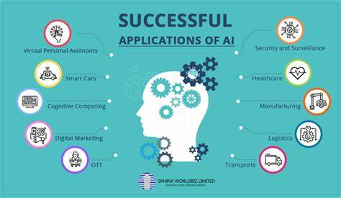

Chapter 4: Understanding Artificial Neural Networks (ANNs)
Artificial Neural Networks (ANNs) are at the heart of artificial intelligence, designed to mimic the way the human brain processes information. These networks are made up of interconnected nodes—much like neurons in our brain—that work together to analyze data, recognize patterns, and make intelligent predictions. power many of the AI-driven technologies we use today.
4.1 Concept and Structure
ANNs are inspired by the human brain’s structure and function, but instead of biological neurons, they use artificial ones that are connected through weighted pathways. These connections.
A typical ANN consists of three main layers:
- Input Layer – This is where the raw data enters the network. Each neuron in this layer represents a feature of the input data, such as pixels in an image or words in a sentence.
- Hidden Layers – These layers perform the actual computations, identifying patterns and relationships in the data. Each neuron in these layers applies a mathematical function—like ReLU, Sigmoid, or Tanh—to determine how much influence an input should have on the final output.
- Output Layer – This layer produces the final result based on the patterns learned by the hidden layers, whether it’s classifying an image, predicting stock prices, or translating a sentence.
To improve accuracy, ANNs use training algorithms like backpropagation, which continuously adjusts the weights of connections between neurons. This process helps minimize errors and fine-tune the network’s ability to make accurate predictions.
4.2 Types of Artificial Neural Networks
Not all ANNs work the same way. Different types of neural networks are designed for different tasks, depending on how they process and analyze data. Here are some of the most widely used ANN models:
1. Feedforward Neural Networks (FNNs)This is the simplest form of ANN, where data flows in one direction—from input to output—without looping back. These networks are commonly used for tasks like classification and regression, where the goal is to categorize data or make numerical predictions.
2. Convolutional Neural Networks (CNN):s are specifically designed to process images in a way that mimics how the human brain recognizes patterns. Instead of analyzing each pixel individually, they use convolutional layers to detect important visual features such as edges, shapes, and textures. This ability makes CNNs particularly powerful in applications like facial recognition, object detection, and medical imaging, where understanding visual patterns is crucial.
3.Recurrent Neural Networks (RNNs)
Unlike traditional feedforward networks, RNNs have a built-in memory mechanism that allows them to process sequences of data while remembering past inputs. This makes them ideal for tasks that involve patterns over time, such as speech recognition, language translation, and predicting future trends in time-series data. However, standard RNNs face limitations, such as the vanishing gradient problem, which makes it difficult for them to retain long-term informationenabling better performance in processing and understanding sequential data.

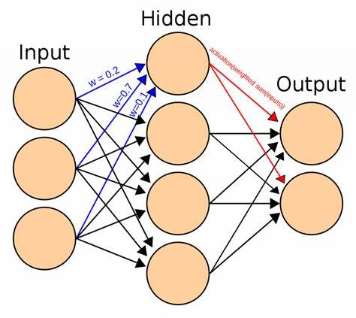

Chapter 5: Support Vector Machines
Support Vector Machines (SVMs) are a supervised machine learning algorithm commonly used for classification and regression tasks. They work by identifying an optimal boundary (hyperplane) that best separates data points into different categories. Due to their effectiveness in handling high-dimensional data, SVMs are widely applied in:
- Text categorization (e.g., spam detection, sentiment analysis)
- Bioinformatics (e.g., gene classification, protein structure prediction)
5.1 How SVMs Work
- The support vectors (data points closest to the hyperplane) define the margin—the wider the margin, the better the model generalizes.
5.2 Types of SVM Kernels
1. Linear Kernel
✔ Used when data is linearly separable (can be divided by a straight line).
✔ Computationally efficient and simple to implement.
2. Polynomial Kernel
✔ Suitable when data has nonlinear relationships.
✔ Maps input features into a higher-degree polynomial space to create complex decision boundaries.
3. Radial Basis Function (RBF) Kernel
✔ The most commonly used kernel, ideal in nonlinear classification.
✔ Maps into an infinite-dimensional space, allowing it to handle complex decision boundaries.
Works well when there is no clear separation in the original feature space.

5.4 Challenges of SVMs
1. High Computational Demand – Training Support Vector Machines (SVMs) can be resource-intensive, requiring significant processing power and memory, particularly when working with large datasets.
2. Sensitive to Parameter Selection—The effectiveness of SVMs heavily depends on selecting the right parameters, such as the kernel type, regularization factor, and gamma values. Fine-tuning these parameters is essential for optimal performance but can be complex.
3.Limited Scalability – While SVMs perform well on moderate-sized datasets, they may struggle with very large datasets. In such cases, deep learning models or algorithms like Random Forests often provide better efficiency and accuracy.
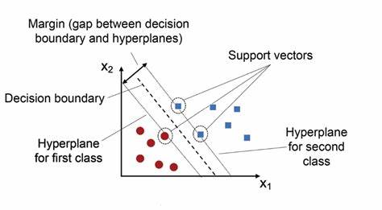

Chapter 6: Regression in AI
Regression is a key technique in artificial intelligence (AI) and machine learning that helps analyze data and make predictions based on past trends. It allows us to understand how different factors influence each other and is widely used in industries like finance, healthcare, marketing, and engineering. Whether it’s forecasting stock prices, predicting patient outcomes, or optimizing marketing strategies, regression helps AI systems identify patterns in historical data to make informed decisions. By improving accuracy and supporting better decision-making, regression plays a crucial role in shaping smarter business strategies and real-world applications
6.1 Definition and Importance
Regression analysis is a statistical method that models the relationship between a dependent variable (target) and one or more independent variables (predictors). In AI, regression plays a crucial role in supervised learning, where goal is predict continuous values such as stock prices, customer demand, or disease progression. Unlike classification, which categorizes data into discrete groups, regression focuses on estimating numerical values.
The importance of regression in AI lies in its ability to quantify relationships between variables, detect trends, and improve decision-making through data-driven insights. Businesses use regression models for demand forecasting, risk assessment, and customer behavior analysis, while scientists apply them in fields like climate modeling and medical research. Regression techniques also serve as the foundation for more complex machine learning algorithms, making them essential for AI development.
6.2 Types of Regression
6.2.1 Linear Regression
Linear regression is one of the simplest and most widely used regression techniques. It assumes a linear relationship between the dependent and independent variables and models this relationship using a straight-line equation:
Y=β0+β1X+ϵY = \beta_0 + \beta_1X + \epsilon
In economics for assessing market trends, and in business for sales forecasting. Despite its simplicity, linear regression can be very effective when the relationship between variables is truly linear. However, it struggles with capturing complex patterns in data, making it less suitable for real-world scenarios where relationships are often nonlinear.
6.2.2 Logistic Regression
It predicts the probability of an outcome belonging to a particular category,

making it ideal for binary classification problems such as spam detection, medical diagnosis (e.g., predicting whether a tumor is malignant or benign), and credit risk assessment.
The model uses the sigmoid function to map predicted values between 0 and 1:
P(Y=1)=11+e−(β0+β1X)P(Y=1) = \frac{1}{1 + e^{-(\beta_0 + \beta_1X)}}
where P(Y=1)P(Y=1) represents the probability of the positive class. If the output is greater than a certain threshold (usually 0.5), the model classifies the instance as belonging to class 1; otherwise, it assigns it to class 0. Logistic regression is widely used because of its interpretability and efficiency, though it may struggle with complex relationships that require more advanced techniques like neural networks.
6.2.3 Polynomial Regression
Polynomial regression extends linear regression by introducing polynomial terms, allowing it to model nonlinear relationships. Instead of fitting a straight line, it fits a curve to the data using an equation like:
Y=β0+β1X+β2X2+β3X3+...+βnXn+ϵY = \beta_0 + \beta_1X + \beta_2X^2 + \beta_3X^3 + ... + \beta_nX^n + \epsilon
where nn is degree of the polynomial. Higher-degree polynomials enable the model to capture intricate patterns, making polynomial regression useful in fields such as physics (modeling motion trajectories), finance (predicting asset prices), and engineering (analyzing stress-strain curves). However, if the degree is too high, the model may overfit.
6.2.4 Ridge and Lasso Regression
When dealing with high-dimensional data with many features, multicollinearity (when independent variables are highly correlated) can affect the performance of regression models. Ridge and Lasso regression address this issue by applying regularization techniques that prevent overfitting.
- Ridge Regression: Adds a penalty term (L2 regularization) to the loss function, which helps shrink the coefficients of less important variables. It is useful when all predictors contribute to the outcome, but their individual impacts need to be minimized to prevent overfitting.
- Lasso Regression: Uses L1 regularization, which not only penalizes large coefficients but also forces some coefficients to become zero. This makes Lasso regression useful for feature selection, as it automatically eliminates irrelevant variables from the model.
Both techniques are widely used in scenarios where datasets contain a large number of variables, such as genetics (identifying significant genes affecting diseases) and marketing (determining key factors influencing consumer behavior).
6.3 Applications in Various Fields
Regression models are applied across multiple industries to support decision-making, optimize performance, and improve predictions.
- Healthcare: Regression analysis helps in predicting disease outbreaks, estimating patient survival rates, and assessing the impact of treatments. For example, linear regression is used to predict blood sugar levels based on diet and exercise patterns.
- Finance: Banks and investment firms use regression for stock market predictions, credit scoring, and risk analysis. Logistic regression, for instance, is widely applied in fraud detection and loan default prediction.
- Marketing: Businesses leverage regression models to analyze customer behavior, predict sales trends, and optimize advertising campaigns.
- Climate Science: Regression techniques are used to forecast weather patterns, analyze temperature trends, and model climate change effects. Ridge and Lasso regression are particularly helpful when working with complex environmental datasets.
- Engineering: Regression models are crucial in quality control, process optimization, and predicting equipment failures. Polynomial regression, for example, is used in aerodynamics to model airflow over aircraft wings.
Regression remains a foundational tool in AI and ml. enabling accurate predictions insightful & data analysis
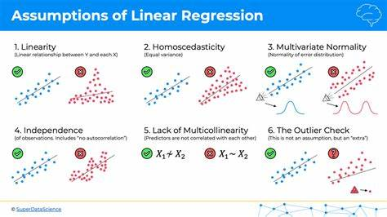

Chapter 7: Ethical and Social Implication of AI
Ethical and Social Implications of Artificial Intelligence.
The rapid growth of Artificial Intelligence (AI) is transforming industries, making processes more efficient, improving decision-making, and driving innovation. However, while AI brings numerous benefits, it also raises important ethical and societal concerns that need to be carefully managed. Challenges such as biased decision-making, threats to data privacy, and the effects of automation on jobs highlight the need for responsible AI development. As AI becomes a bigger part of our everyday lives, ensuring fairness, security, and overall societal well-being is crucial for its long-term success and acceptance.
AI models learn from vast datasets, and if these datasets contain biases, the AI system may unintentionally reinforce and perpetuate them. This can result in unfair or, discriminatory outcomes in areas like recruitment, finance, law enforcement, and healthcare. For example:
- Facial recognition technologies have shown higher error rates when identifying individuals from underrepresented demographic groups, leading to potential racial or gender biases.
- Automated hiring systems may favor certain candidates over others, not based on merit but due to biases in historical hiring data.
To minimize bias and promote fairness in AI, developers must ensure that datasets are diverse, inclusive, and representative of different populations. Additionally, increasing transparency in AI decision-making and continuously monitoring models for unfair patterns is essential. The development of fairness-aware algorithms and adherence to regulatory frameworks can further promote ethical AI usage, ensuring that AI-driven decisions do not unintentionally disadvantage certain groups.

7.2 Privacy and Security Concerns
AI relies heavily on personal data to function effectively, raising concerns about data privacy, security, and potential misuse. Applications such as personalized recommendations, healthcare diagnostics, and facial recognition require sensitive information, making them susceptible to data breaches and unethical exploitation. Key concerns include:
- AI-driven surveillance, which may infringe on personal freedoms by enabling mass monitoring.
- Cybersecurity threats, where AI can be misused for cyberattacks, such as deepfake manipulation or AI-powered hacking.
To protect user privacy and maintain trust in AI systems, it is crucial to implement strong data encryption, secure user consent mechanisms, and ethical data collection practices. Additionally, global regulations, such as the General Data Protection Regulation (GDPR), provide essential legal frameworks that help ensure AI systems operate within ethical and legal boundaries, preventing unauthorized data usage.
7.3 Job Displacement and Workforce Adaptation
AI-driven automation is reshaping industries by enhancing productivity and streamlining processes. However, as AI takes over repetitive and routine tasks, concerns about job displacement and economic inequality have emerged. Examples include:
- Manufacturing, customer service, and transportation sectors experiencing workforce reductions due to automation.
- Traditional roles being replaced by AI-powered systems, leading to uncertainty about future employment.
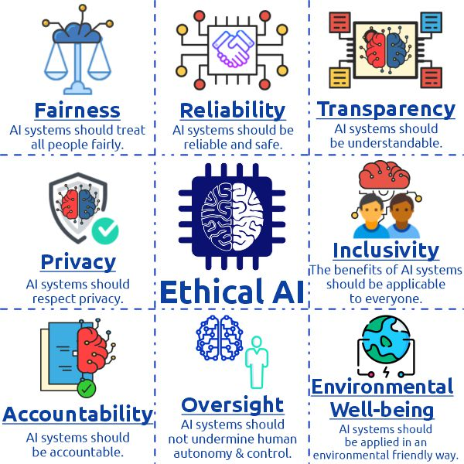
Chapter 8: Future of AI
AI is evolving at a remarkable pace, transforming industries, reshaping society, and redefining how humans engage with technology. As it continues to progress, AI is expected to unlock new innovations, influence social dynamics, and present challenges that require thoughtful regulation and oversight. While the future of AI offers incredible opportunities, it is equally important to address ethical concerns, establish clear guidelines, and proactively manage risks to ensure its development remains responsible and beneficial for all.
8.1 Advancing in AI Technologies
AI technology is evolving rapidly, with major breakthroughs in deep learning, natural language processing (NLP), and reinforcement learning. Some of the most notable emerging trends include:
- Generative AI – Technologies like ChatGPT and deepfake applications are advancing content creation, offering new possibilities in automation, media, and communication.
- Explainable AI (XAI) – Efforts to make AI decision-making more transparent and interpretable are gaining traction, helping users understand how AI-driven outcomes are generated.
- Quantum AI –like drug discovery, cryptography, and complex problem-solving by accelerating computational capabilities.
As AI research continues to progress, these innovations will drive improvements in efficiency, personalization, and decision-making across various domains, transforming the way industries operate and enhancing everyday experiences.
8.2 How AI plays in Society
AI is set to become an integral part of society, influencing everything from healthcare and education to governance and global connectivity. Some key areas where AI is making a significant impact include:
- Healthcare – AI is enhancing medical diagnostics, accelerating drug discovery, and enabling personalized treatment plans, leading to improved patient outcomes.
- Education – AI-powered adaptive learning systems tailor educational content to individual student needs, providing a more engaging and effective learning experience.
- Governance and Smart Cities – AI is aiding urban planning and policy-making by optimizing traffic systems, public services, and resource allocation, leading to smarter, more efficient cities.
- Global Connectivity – AI-powered real-time translation is bridging language gaps, enabling seamless communication and collaboration across different cultures and regions.
- While AI offers transformative benefits, it also raises important ethical concerns related to privacy, bias, and digital dependence. To ensure these technologies serve everyone fairly and transparently, continuous ethical oversight and responsible implementation are essential.
8.3 Potential Risks and Challenges
- Despite its many advantages, AI also comes with risks that must be carefully managed to ensure its safe and ethical use.
- Privacy and Data Security – AI systems process vast amounts of sensitive data, raising concerns about privacy, potential data breaches, and the misuse of personal information.
- Job Displacement – The increasing adoption of AI-driven automation may replace jobs in industries reliant on repetitive tasks, potentially contributing to economic inequality.
- AI Misuse – The rise of deepfake technology, autonomous weapons, and cyber threats highlights the potential for AI to be used maliciously, posing risks to security and public trust.
To address these risks, collaboration between governments, technology companies, and researchers is crucial. By implementing strong regulations, ensuring accountability, and putting protective measures in place, we can minimize unintended consequences while encouraging the ethical and responsible advancement of AI.
The future of AI presents limitless opportunities for progress, but its development must be guided by responsible innovation and ethical oversight. By embracing AI’s advancements while proactively addressing its risks, society can harness its full potential to drive positive change, enhance human capabilities, and create a more inclusive and sustainable future.

Chapter 9: Introduction to CNNs
9.1 Evolution of Neural Networks Leading to CNNs
Neural networks have evolved significantly over the past few decades. Initially, simple feedforward networks were used, where data moves in one direction from input to output without loops. Although they performed well for basic tasks, they struggled with complex data like images, where spatial patterns and relationships matter. To handle such complexity, researchers introduced Convolutional Neural Networks (CNNs). particularly how the visual cortex identifies patterns like edges and textures. By using convolutional layers, CNNs can automatically detect features directly from raw images, removing the need for manual feature extraction. This major advancement transformed neural networks from simple pattern recognizers to powerful tools capable of solving real-world problems in vision and beyond.
9.2 Importance in Computer Vision Tasks
CNNs have become the foundation of modern computer vision. Unlike traditional approaches that required handcrafted features, CNNs learn to identify important patterns, such as shapes and textures, directly from data. Their ability to capture spatial hierarchies — starting from simple edges to more complex objects — makes them highly effective for a wide range of visual tasks. From classifying images into categories, detecting objects within scenes, to segmenting images pixel by pixel, CNNs have pushed the boundaries of what machines can "see" and understand. Their robustness, adaptability, and high accuracy have made CNNs the backbone of applications like facial recognition, autonomous driving, medical imaging, and even augmented reality. CNNs revolutionized computer vision by allowing end-to-end learning. Unlike traditional methods where feature extraction and classification were separate steps, CNNs combine both into one unified framework. This means that CNNs can learn to extract the best features for a specific task during the training process itself, which improves accuracy and efficiency.
In real-world applications, CNNs are everywhere:
- Healthcare: CNNs help doctors detect diseases in X-rays, MRIs, and CT scans more accurately and faster than manual diagnosis.
- Security: Facial recognition systems at airports and smartphones rely heavily on CNN-based models.
- Self-driving Cars: Autonomous vehicles use CNNs to identify pedestrians, traffic signs, and other vehicles to safely navigate roads.
- Social Media: Platforms like Instagram and Facebook use CNNs to tag people in photos automatically and to recommend visual content.
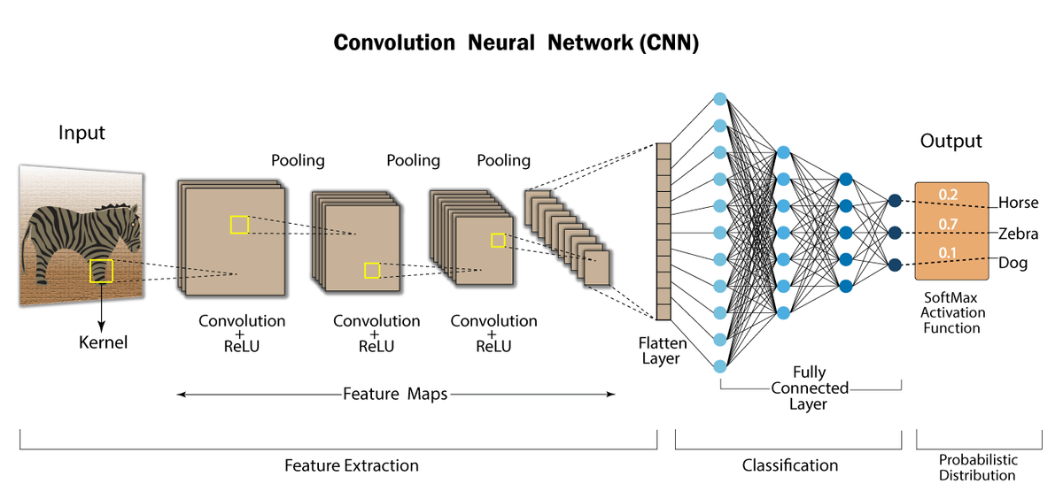

Chapter 10: Basic Building Blocks

10.1 Convolutional Layerss
Convolutional layers are the heart of any CNN. Their main job is to detect different patterns or features in the input data, such as edges, corners, or textures. Instead of connecting every input pixel to every output node (like in fully connected layers), convolutional layers apply a small filter or kernel that slides across the input image. the filter performs a mathematical operation called a convolution, producing a feature map that highlights important patterns. Each filter is trained to recognize a specific type of feature. As we add more layers, the network can learn increasingly complex structures — from simple lines in early layers to whole objects like faces or animals in deeper layers.

10.2 Activation Functions (ReLU and Others)
After the convolution operation, activation functions are applied to introduce non-linearity into the model. Without non-linear functions, a CNN would just behave like a simple linear classifier, no matter how many layers it had. The most common activation function in CNNs is the Rectified Linear Unit (ReLU), which transforms any negative value to zero while keeping positive values unchanged. This helps the model learn faster and makes it more efficient. Apart from ReLU, other activation functions like Sigmoid, Tanh, and Leaky ReLU are also used in certain cases, depending on the task. Each activation function has its own advantages and choosing the right one can affect the network’s performance.

10.3 Pooling Layers (Max Pooling, Average Pooling)
Pooling layers are used to reduce the dimensions of feature maps while keeping the most important information. This makes the network faster and helps prevent overfitting. In max pooling, the largest value within a small window is selected, capturing the most dominant feature in that region. In average pooling, the average of all the values in the window is taken, providing a smoother, more generalized feature representation. By reducing the size of the data step by step, pooling layers make it easier for CNNs to focus on the big picture rather than getting stuck on small details.

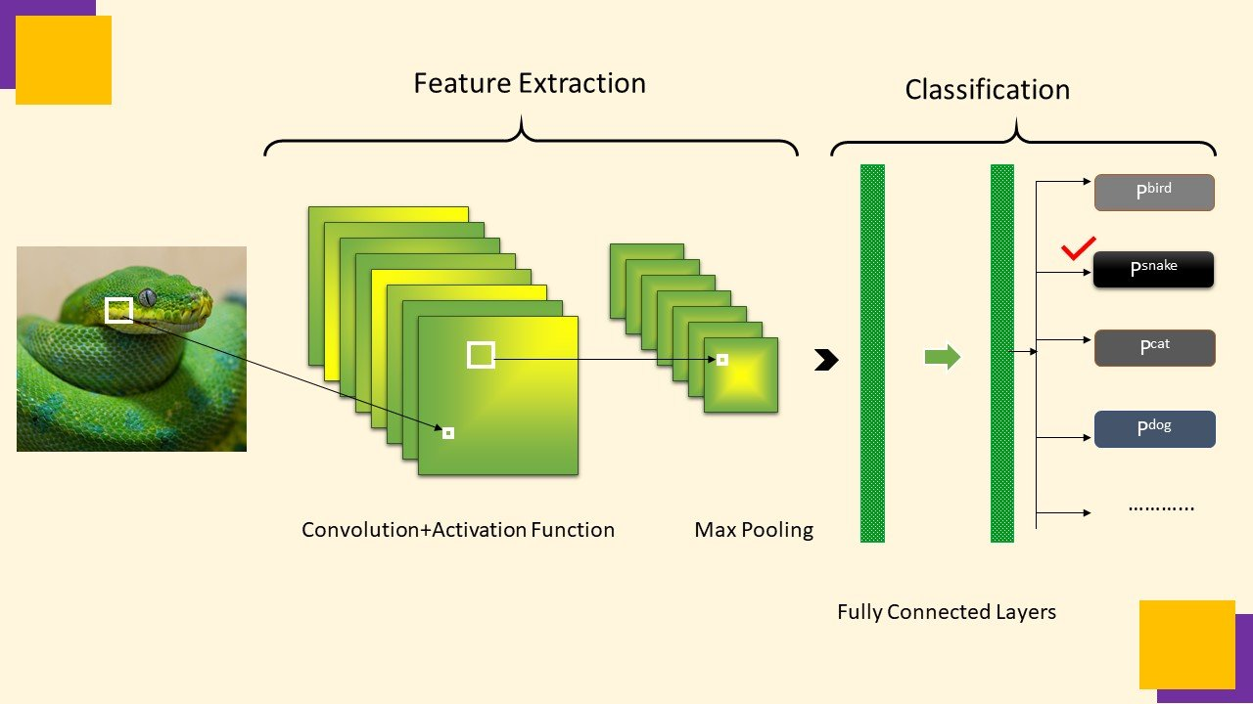

Chapter 11: Advanced Layers and Techniques
11.1 Batch Normalization
Batch normalization is an essential technique in modern deep learning, introduced to address the problem of internal covariate shift. As inputs pass through multiple layers, their distributions can change, making the network harder to train. Batch normalization solves this by normalizing the inputs to each layer so that they have a mean of zero and a standard deviation of one. It not only speeds up the training process but also provides a slight regularization effect, reducing the need for other methods like dropout in some cases. During training, the normalization is done using the statistics of each mini-batch; during testing, running averages are used. Batch normalization also allows for the use of higher learning rates, making convergence faster and improving the stability of very deep networks. Today, it is almost standard practice to insert batch normalization layers after convolutions and before applying activation functions like ReLU.
11.2 Dropout for Regularization
Dropout is a simple yet highly effective regularization technique designed to combat overfitting, especially in deep neural networks. During training, dropout randomly deactivates a set percentage of neurons in a layer at chance. This means in each iteration, the network learns with a different set of neurons, forcing it not to rely too heavily on any single neuron or pathway. The "dropout rate" defines how much of the network is temporarily dropped; a typical value is 0.5 for dense layers and around 0.2–0.3 for convolutional layers. At inference time (testing or deployment), all neurons are active, but their outputs are scaled to account for the dropped neurons during training. Dropout improves generalization and is often used alongside other regularization techniques like data augmentation and weight decay.
11.3 Fully Connected (Dense) Layers
Fully connected, or dense, layers are a key component in neural networks, especially near the output stage. In these layers, each neuron receives input from every neuron in the previous layer. After convolutional and pooling layers have extracted and compressed feature maps from input data (such as an image), dense layers use these features to make predictions. For example, in image classification, a dense layer can transform high-level features into class probabilities using a softmax activation function. Although fully connected layers are powerful, they tend to have a large number of parameters, which can increase the risk of overfitting if not managed carefully. Techniques like dropout and regularization are often applied to dense layers to ensure better generalization. In modern CNN architectures, dense layers are used sparingly, often preceded by flattening operations that convert multidimensional feature maps into one-dimensional vectors.

Chapter 12: Popular CNN Architectures
12.1 LeNet-5
LeNet-5 is one of the earliest and most influential convolutional neural network models, developed by Yann LeCun and his team in 1998. Originally designed for handwritten digit recognition (such as digits from postal codes), LeNet-5 laid the foundation for modern CNNs. The architecture consists of two sets of convolutional and pooling layers, followed by fully connected layers that produce the final classification output. A key feature of LeNet-5 is its simplicity and efficiency: it introduced core ideas like local receptive fields, shared weights, and subsampling, which are still used in today's deep networks. Although modest compared to today's standards.
12.2 AlexNet
AlexNet marked a major breakthrough in deep learning by winning the ImageNet Large Scale Visual Recognition Challenge (ILSVRC) in 2012 with a wide margin. Scientists proved that deep CNNs could outperform traditional computer vision methods on large-scale datasets. The network consists of five convolutional layers followed by three fully connected layers. It introduced several innovations, such as using the ReLU activation function to speed up training and applying dropout to reduce overfitting. Another important feature was the use of GPUs to accelerate training, making it feasible to train deeper networks on large datasets. AlexNet's success sparked a revolution in computer vision and deep learning research.
12.3 VGGNet
VGGNet, introduced by the Visual Geometry Group at the University of Oxford, made a significant impact by showing that deeper networks could improve performance if designed carefully. The key idea behind VGGNet is simplicity: it uses only 3x3 convolutional filters stacked on top of each other, increasing depth to 16 or 19 weight layers (VGG16 and VGG19). This approach allows the network to learn complex features while maintaining manageable computational complexity. Although VGGNet is computationally heavy and memory-intensive compared to newer models, it remains popular for its elegant and straightforward design.
12.4 ResNet
ResNet, short for Residual Network, addressed one of the biggest challenges in deep learning: training very deep networks without running into vanishing gradient problems. Introduced by Kaiming He and his team in 2015, ResNet proposed the idea of "skip connections" or "residual connections," where the input to a layer is added directly to the output of a deeper layer. This allows gradients to flow more easily through the network during backpropagation, making it possible to train extremely deep models like ResNet-50, ResNet-101, and even deeper versions. ResNet's innovative design won the ILSVRC 2015 competition and became a foundation for many later architectures, including efficient variants and transformer-based models.

12.5 MobileNet
MobileNet was designed with efficiency in mind, targeting mobile devices and applications where computational resources are limited. Developed by Google, MobileNet introduces a technique called depthwise separable convolution, which dramatically reduces the number of parameters and computational cost without sacrificing much accuracy. Instead of using a standard convolution that simultaneously filters and combines inputs into a new set of outputs, MobileNet separates these two tasks into two smaller operations, making the network lighter and faster. MobileNet models, like MobileNetV1, V2, and V3, are widely used for mobile and embedded facial recognition on smartphones and edge devices.
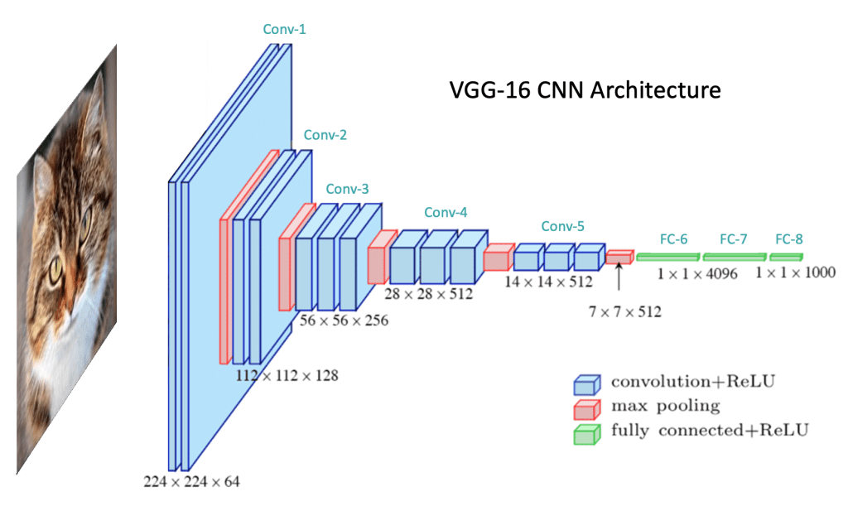

Chapter 13: Applications of CNNs
13.1 Image Classification
Image classification is one of the most well-known and widely used applications of Convolutional Neural Networks (CNNs). The task involves categorizing an image into one of several predefined classes based on its content. CNNs excel at this task due to their ability to automatically learn hierarchical features from raw image data. Early layers of the network detect basic features like edges and textures, while deeper layers combine these features to recognize complex patterns such as faces, animals, or objects. Popular examples include image recognition tasks like classifying photos in the ImageNet challenge, where CNNs have consistently achieved state-of-the-art performance. Image classification is fundamental in various applications such as medical diagnostics (e.g., detecting diseases in X-rays), facial recognition, and organizing large image databases.
13.2 Object Detection
Object detection extends image classification by not only identifying what is in an image but also locating where specific objects are within the image. This involves both classification and localization tasks. CNN-based modelshave revolutionized object detection. They use convolutional layers to extract features and then apply bounding boxes around detected objects, along with classifying them. These models are widely used in autonomous vehicles for detecting pedestrians, traffic signs, and other cars, in surveillance systems for identifying people or objects, and in robotics for object manipulation and recognition. The challenge lies in detecting multiple objects in various orientations, scales, and occlusions, and CNNs excel at handling these complexities.
13.3 Image Segmentation
Image segmentation is the process of partitioning an image into multiple segments or regions, often corresponding to different objects or meaningful parts of the scene. While object detection localizes objects with bounding boxes, image segmentation goes a step further by labeling each pixel in an image with a class. CNNs, especially architectures like U-Net and Fully Convolutional Networks (FCNs), are highly effective for segmentation tasks. These networks use an encoder-decoder structure to capture both high-level features (for classification) and low-level details (for accurate pixel-level segmentation). Image segmentation has numerous applications, such as medical imaging (segmenting tumors or organs in CT scans), autonomous driving (segmenting roads, pedestrians, and vehicles), and satellite imaging (identifying land use or environmental changes).
13.4 Style Transfer and Super-Resolution
CNNs have also been used for creative applications, such as style transfer and super-resolution. Style transfer involves taking the content of one image and applying the artistic style of another image, creating an image that blends both. CNNs, particularly the VGG network, have been successful in transferring styles by utilizing the deep layers of the network to separate content and style. In super-resolution, CNNs are used to enhance the resolution of low-resolution images by predicting high-frequency details and filling in missing information. This technique is widely used in improving old photographs, satellite images, and medical imaging where high-resolution data is crucial for accurate diagnosis. Both applications show the versatility of CNNs beyond traditional image recognition tasks, opening up new possibilities in art, entertainment, and media.

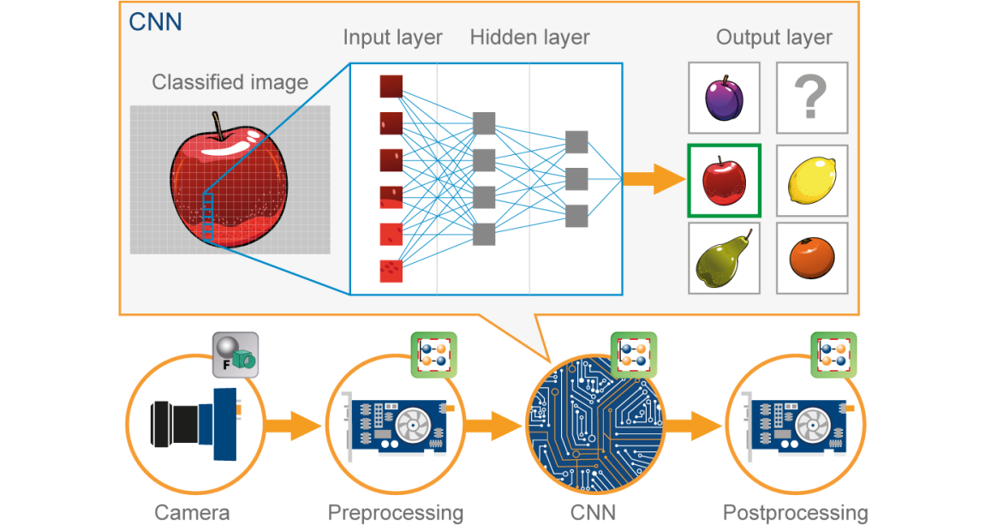

Chapter 14: Training CNNs
14.1 Loss Functions (Cross-entropy, etc.)
Loss functions are essential for guiding the learning process of Convolutional Neural Networks (CNNs). They measure how well the model's predictions match the actual labels, providing feedback to the network on how to adjust its parameters. Cross-entropy loss is one of the most commonly used loss functions, particularly for classification tasksIn binary classification, it's referred to as binary cross-entropy, and for multi-class classification, it's known as categorical cross-entropy. Cross-entropy loss heavily penalizes incorrect predictions, especially when model confident about its wrong predictions, thus helping the model learn quickly.
For regression tasks, where the goal is to predict continuous values, mean squared error (MSE) is typically used. Other specialized loss functions, such as hinge loss (used in support vector machines), may also be applied in specific contexts, but cross-entropy remains the most popular choice for many classification problems due to its strong theoretical foundations in information theory.
14.2 Optimizers (SGD, Adam)
Optimizers are algorithms used to update the weights of the network in order to minimize the loss function. Stochastic Gradient Descent (SGD) is the most fundamental optimization algorithm. In SGD, the weights are updated based on the gradient of the loss function with respect to the parameters, calculated on a small batch of data (hence "stochastic"). This allows for more frequent updates and can accelerate learning, especially for large datasets. However, SGD can be slow to converge and may get stuck in local minima or saddle points.
To address this limitations, more advanced optimizers like Adam (short for Adaptive Moment Estimation) have been developed. Adam combines the advantages of both momentum (which accelerates gradients in the relevant direction) and adaptive learning rates (which adjust the learning rate for each parameter individually based on past gradients). As a result, Adam often converges faster than SGD and is more robust to hyperparameter choices
14.3 Data Augmentation Strategies
This is especially useful when working with limited data, as it helps prevent overfitting and encourages the model to generalize better. Common data augmentation strategies flipping, cropping, scaling, and color adjustments. For image data, transformations like shearing, zooming, and translation are also frequently applied.
Data augmentation works by creating slightly modified versions of the original data, allowing the model to learn from a broader set of variations and making it less likely to memorize the training set. For example, in a task like image classification, augmenting the images by rotating or flipping them can simulate different viewpoints of the same object, helping the model recognize it under various conditions. This technique is vital in domains like medical imaging, where data is often scarce but is crucial for training accurate models.

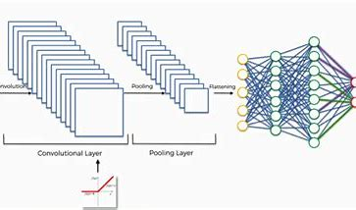

Chapter 15: Challenges and Solutions
15.1 Overfitting and Underfitting
Overfitting and underfitting are two common problems that arise when training deep learning models like Convolutional Neural Networks (CNNs).
- Overfitting occurs when a model learns the training data too well, including the noise and minor fluctuations, rather than learning the general patterns. As a result, the model performs very well on the training set but poorly on unseen data (test set). Signs of overfitting include a large gap between training and validation accuracy. Solutions to overfitting include techniques such as dropout.
- Underfitting, on the other hand, happens when the model is too simple or not trained enough to capture the underlying patterns in the data. An underfitted model shows poor performance on both the training and validation sets. To overcome underfitting, one can use a more complex model, train for more epochs, adjust the learning rate, or improve feature engineering.
15.2 Vanishing and Exploding Gradients
The problems of vanishing and exploding gradients occur during the training of deep neural networks, especially when there are many layers.
- Vanishing gradients. This slows down learning significantly, making it almost impossible for the model to update the weights of the earlier layers. As a result, the network fails to learn deep features. This issue often arises when using activation functions like sigmoid or tanh in deep networks.
- Exploding gradients are the opposite. This can lead to unstable training and the model's loss diverging instead of decreasing.
Solutions to these problems include using ReLU activation functions (which help prevent vanishing gradients), gradient clipping (to control large gradients), proper weight initialization (such as He or Xavier initialization), and advanced architectures like ResNet, which introduce skip connections to help gradients flow more easily across layers.
15.3 Computational Cost and Solutions
Training deep CNNs can be extremely computationally expensive, requiring large amounts of memory, processing power, and time, especially for high-resolution images or very deep architectures. The computational demands can slow down research and increase infrastructure costs.
Several strategies can help manage and reduce computational cost:
- Model pruning, which involves removing unnecessary neurons and connections to make the network smaller and faster without significant loss in performance.
- Quantization and knowledge distillation, which help create lighter models suitable for deployment on devices with limited resources.
- Efficient architectures like MobileNet, SqueezeNet, and EfficientNet are specifically designed to perform well while using fewer computational resources.
- Training on GPUs or TPUs and using distributed training across multiple machines can also significantly speed up the training process.
By carefully choosing network architectures, training methods, and hardware resources, it is possible to train powerful CNNs even with limited budgets.

Conclusion:
Artificial Intelligence (AI) is no longer a distant concept—it has become an integral part of our daily lives, transforming industries and redefining how we interact with technology. At the heart of this transformation and regression analysis. These technologies help machines learn, recognize patterns, and make intelligent decisions, driving progress in healthcare, finance, education, transportation, and beyond.
Artificial Neural Networks (ANNs) are modeled after the human brain, allowing computers to process and interpret complex data in ways once impossible. They are the backbone of deep learning, powering applications like facial recognition, virtual assistants, and self-driving cars. Similarly, SVMs excel at classifying and predicting patterns in vast amounts of data, making them invaluable for detecting fraud, diagnosing diseases, and improving cybersecurity. Regression techniques, whether linear, logistic, or more advanced variations, help AI analyze trends and predict future outcomes—whether it’s forecasting stock market trends, assessing healthcare risks, or improving business strategies.
Despite AI’s incredible potential, it also brings ethical and societal challenges that cannot be ignored. AI systems can inadvertently reinforce biases if they are trained on imbalanced data, leading to unfair outcomes in hiring, lending, and law enforcement. Transparency in AI decision-making is crucial to ensure fairness and accountability. Privacy concerns also arise as , surveillance, and consent. Additionally, the rise of AI-driven automation is reshaping the job market, replacing some traditional roles while simultaneously creating new opportunities in data science, robotics, and AI ethics.
Looking to the future, AI is set to become even more powerful with advancements in neural networks, SVM techniques, and predictive models. Emerging fields like explainable AI and quantum computing promise to make AI more transparent, efficient, and capable of solving complex problems. However, as AI continues to evolve, it must be developed and deployed responsibly. Governments, businesses, and researchers must work together to establish ethical guidelines, regulatory frameworks, and safeguards that prioritize fairness, security, and human well-being.
AI has the potential to be one of the most transformative forces of our time, but its impact depends on how it is guided and implemented. By addressing its challenges and ensuring that it benefits society as a whole, AI can enhance human potential, drive innovation, and create a future where technology serves humanity in a responsible and equitable way. Convolutional Neural Networks (CNNs) have revolutionized the field of computer vision and beyond by providing models that can automatically learn hierarchical features from raw data. Their unique architecture, consisting of convolutional layers, activation functions, and pooling mechanisms, allows them to excel in recognizing patterns such as edges, textures, and complex objects. Over the years, advancements like batch normalization, dropout, ResNet and MobileNet have further strengthened the capabilities of CNNs. Despite challenges like overfitting, vanishing gradients, and high computational costs, various solutions have made CNNs both powerful and practical. Today, CNNs are at the core of many groundbreaking applications, including image classification, object detection, and medical imaging, making them an indispensable tool in the world of artificial intelligence.

References:
Here are the references with links for further reading on AI, SVM, and Regression:
Artificial Intelligence (AI)
- Russell, S., & Norvig, P. (2016). Artificial Intelligence: A Modern Approach (3rd ed.). Pearson.
Link to Book
- Goodfellow, I., Bengio, Y., & Courville, A. (2016). Deep Learning. MIT Press.
Link to Book
- Mitchell, T. M. (1997). Machine Learning. McGraw-Hill.
Link to Book
Support Vector Machines (SVM)
- Cortes, C., & Vapnik, V. (1995). Support-vector networks. Machine Learning, 20(3), 273-297.
Link to Paper
- Boser, B. E., Guyon, I. M., & Vapnik, V. N. (1992). A training algorithm for optimal margin classifiers. Proceedings of the Fifth Annual ACM Workshop on Computational Learning Theory.
Link to Paper
- Schölkopf, B., & Smola, A. J. (2002). Learning with Kernels: Support Vector Machines, Regularization, Optimization, and Beyond. MIT Press.
Link to Book
Regression
- James, G., Witten, D., Hastie, T., & Tibshirani, R. (2013). An Introduction to Statistical Learning: With Applications in R. Springer.
Link to Book
- Hastie, T., Tibshirani, R., & Friedman, J. (2009). The Elements of Statistical Learning: Data Mining, Inference, and Prediction (2nd ed.). Springer.
Link to Book
- Pedregosa, F., Varoquaux, G., Gramfort, A., Michel, V., Thirion, B., Grisel, O., ... & Duchesnay, E. (2011). Scikit-learn: Machine learning in Python. Journal of Machine Learning Research, 12, 2825-2830.
Link to Paper
General AI, SVM, and Regression Resources
- Sutton, R. S., & Barto, A. G. (2018). Reinforcement Learning: An Introduction (2nd ed.). MIT Press.
Link to Book
- Bishop, C. M. (2006). Pattern Recognition and Machine Learning. Springer.
Link to Book
- • LeCun, Y., Bottou, L., Bengio, Y., & Haffner, P. (1998). Gradient-based learning applied to document recognition. Proceedings of the IEEE, 86(11), 2278–2324. https://doi.org/10.1109/5.726791
- • Krizhevsky, A., Sutskever, I., & Hinton, G. E. (2012). ImageNet Classification with Deep Convolutional Neural Networks. Advances in Neural Information Processing Systems, 25. https://doi.org/10.1145/3065386
- • Simonyan, K., & Zisserman, A. (2015). Very Deep Convolutional Networks for Large-Scale Image Recognition. arXiv preprint arXiv:1409.1556. https://arxiv.org/abs/1409.1556
- • He, K., Zhang, X., Ren, S., & Sun, J. (2016). Deep Residual Learning for Image Recognition. Proceedings of the IEEE Conference on Computer Vision and Pattern Recognition (CVPR), 770–778. https://doi.org/10.1109/CVPR.2016.90
- • Howard, A. G., Zhu, M., Chen, B., Kalenichenko, D., Wang, W., Weyand, T., ... & Adam, H. (2017). MobileNets: Efficient Convolutional Neural Networks for Mobile Vision Applications. arXiv preprint arXiv:1704.04861. https://arxiv.org/abs/1704.04861
- • Goodfellow, I., Bengio, Y., & Courville, A. (2016). Deep Learning. MIT Press. (Chapter 6: Deep Feedforward Networks, Chapter 7: Regularization for Deep Learning, Chapter 8: Optimization for Training Deep Models)
- • Szegedy, C., Liu, W., Jia, Y., Sermanet, P., Reed, S., Anguelov, D., ... & Rabinovich, A. (2015). Going Deeper with Convolutions. Proceedings of the IEEE Conference on Computer Vision and Pattern Recognition (CVPR). https://doi.org/10.1109/CVPR.2015.7298594
- • Ioffe, S., & Szegedy, C. (2015). Batch Normalization: Accelerating Deep Network Training by Reducing Internal Covariate Shift. Proceedings of the 32nd International Conference on Machine Learning (ICML). https://arxiv.org/abs/1502.03167
- • Srivastava, N., Hinton, G., Krizhevsky, A., Sutskever, I., & Salakhutdinov, R. (2014). Dropout: A Simple Way to Prevent Neural Networks from Overfitting. Journal of Machine Learning Research, 15(1), 1929–1958.
- • Ronneberger, O., Fischer, P., & Brox, T. (2015). U-Net: Convolutional Networks for Biomedical Image Segmentation. arXiv preprint arXiv:1505.04597. https://arxiv.org/abs/1505.04597
- • Kingma, D. P., & Ba, J. (2015). Adam: A Method for Stochastic Optimization. International Conference on Learning Representations (ICLR). https://arxiv.org/abs/1412.6980
- • Zhang, H., Cisse, M., Dauphin, Y. N., & Lopez-Paz, D. (2018). mixup: Beyond Empirical Risk Minimization. International Conference on Learning Representations (ICLR). https://arxiv.org/abs/1710.09412

